Synopsis

Clinical Risk Assessment System for Type-2 Diabetes Using Machine Learning

Problem Id: 07

Student Name: ADARSH MISHRA University Roll number: 2028617 Section: L

Student Name: SHIVAM KUMAR KANU University Roll number: 2028494
Section: L

Problem Description:
Type-2 Diabetes is a chronic metabolic disorder that affects millions of people worldwide. It occurs when the body becomes resistant to insulin or fails to produce enough insulin, leading to elevated blood sugar levels. Early detection of diabetes is crucial because untreated diabetes can lead to severe complications such as heart disease, kidney failure, nerve damage, and vision loss.

This project focuses on developing a machine learning-based clinical risk assessment system to predict whether a person is at risk of Type-2 Diabetes. The system uses synthesized health data including key attributes such as Body Mass Index (BMI), Insulin Levels, blood sugar level and Age. These parameters are medically significant indicators of diabetes risk.

By applying preprocessing techniques such as Label Encoding ,StandardScaler and training a Logistic Regression model, the system aims to classify individuals into diabetic and non-diabetic categories. The performance of the model is evaluated using a Confusion Matrix with a focus on Recall, ensuring that most diabetic cases are correctly identified.

Steps of Implementation:

Data Collection (Health Data Synthesis) :
The present study utilizes a publicly available diabetes dataset sourced from Kaggle, comprising relevant clinical and demographic features of patients. This dataset includes key attributes such as glucose levels, BMI, age, insulin, blood pressure, pregnancies (in females), and other diagnostic parameters essential for diabetes analysis. By leveraging this real-world medical data, the research aims to develop and evaluate machine learning models for early prediction and classification of diabetes mellitus. The primary objective is to identify significant risk factors and patterns associated with diabetes onset, thereby supporting timely diagnosis and preventive healthcare interventions. The selection of this Kaggle dataset ensures reproducibility, facilitates comparison with existing studies, and provides a diverse range of variables crucial for building accurate and reliable predictive models.

Data Preprocessing:
# Display basic information about dataset (columns, data types, non-null values) df_noisy.info()

# Show statistical summary (mean, std, min, max, quartiles) df_noisy.describe()

# Check for missing values in each column df_noisy.isnull().sum()

# Fill missing values in 'BMI' column using mode (most frequent value) df_noisy['BMI'].fillna(df_noisy['BMI'].mode()[0], inplace=True)

# Remove duplicate rows from dataset df_noisy.drop_duplicates(inplace=True)

# Reset index after removing duplicates (clean indexing) df_noisy.reset_index(drop=True, inplace=True)

# ---------------- OUTLIER DETECTION USING IQR METHOD #
# Select only numeric columns
df_numeric = df_noisy.select_dtypes(include=['number'])
# Calculate first quartile (Q1 - 25th percentile) Q1 = df_numeric.quantile(0.25)
# Calculate third quartile (Q3 - 75th percentile) Q3 = df_numeric.quantile(0.75)

# Calculate Interquartile Range (IQR)
IQR = Q3 - Q1

# Define lower and upper bounds for detecting outliers lower_bound = Q1 - 1.5 * IQR
upper_bound = Q3 + 1.5 * IQR

# Remove rows containing outliers
df_clean = df_noisy[~((df_numeric < lower_bound) | (df_numeric > upper_bound)).any(axis=1)]

# Display cleaned dataset df_clean

# ---------------- FEATURE SCALING #

# Select numeric columns again from cleaned data df_numeric = df_clean.select_dtypes(include=['number'])

# Apply Min-Max Scaling (scales values between 0 and 1) scaler = MinMaxScaler()
df_scaled = pd.DataFrame(scaler.fit_transform(df_numeric), columns=df_numeric.columns)

# Display scaled data df_scaled

# ---------------- ENCODING CATEGORICAL DATA #

# Convert categorical variables into numerical using One-Hot Encoding df_encoded = pd.get_dummies(df_clean)

# Display encoded dataset df_encoded

# ---------------- OUTLIER VISUALIZATION #

# Select numeric columns
df_numeric = df_noisy.select_dtypes(include=['number'])

# Boxplot to visually detect outliers df_numeric.boxplot(figsize=(10,6)) plt.title("Boxplot for Outlier Detection") plt.show()

# SCATTER PLOT #

# Print column names to know which columns are being used print(df_numeric.columns)

# Scatter plot between first two numeric columns plt.scatter(df_numeric.iloc[:,0], df_numeric.iloc[:,1])

# Label axes plt.xlabel(df_numeric.columns[0]) plt.ylabel(df_numeric.columns[1])

# Show plot plt.show()

Model Selection :
For this classification problem, Logistic Regression is selected as the machine learning model. This algorithm is suitable because:
  - It works well for binary classification problems
  - It is simple, interpretable, and efficient
  - It provides probability-based predictions useful in healthcare
Lable encoding
le = LabelEncoder()
df["Outcome"] = le.fit_transform(df["Outcome"])
# Diabetic = 1, Non-Diabetic = 0

Code of Model applied
model = LogisticRegression()
model.fit(X_train, y_train)
Training Accuracy
Measures how well the model fits training data
Code- train_accuracy = model.score(X_train, y_train)
print("Training Accuracy:", train_accuracy)
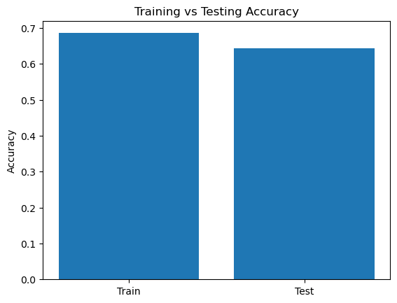
Testing Accuracy
Measures how well the model performs on unseen data
Code- accuracy = model.score(X_test, y_test)
print("Testing Accuracy:", accuracy)
Confusion Matrix
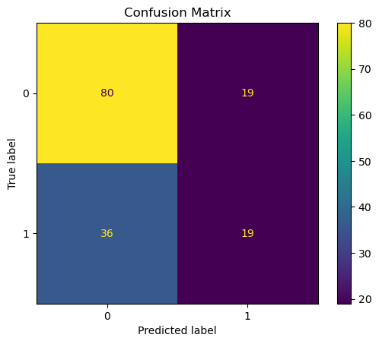
Shows:
  - True Positive (TP)
  - True Negative (TN)
  - False Positive (FP)
  - False Negative (FN)
Code-- cm = confusion_matrix(y_test, y_pred)
print("Confusion Matrix:", cm)
cm = confusion_matrix(y_test, y_pred)

disp = ConfusionMatrixDisplay(confusion_matrix=cm)
disp.plot()

plt.title("Confusion Matrix")
plt.show()

print("Classification Report:")
print(classification_report(y_test, y_pred))

Training and Validation :
The dataset is divided into training (80%) and testing (20%) sets. The Logistic Regression model is trained using the training dataset. After training, the model is tested on unseen data (test set) to evaluate how well it generalizes to new patient data.
Applied train test split finction for training and validation
Code--X = df[["Age", "BMI", "Insulin"]]
y = df["Outcome"]

X_train, X_test, y_train, y_test = train_test_split(X, y, test_size=0.2
, random_state=42)

Evaluation
The model performance is evaluated using:
- Confusion Matrix (Primary focus)
- Recall Score (Most Important)
- Accuracy, Precision, and F1-Score

Special emphasis is given to Recall, because in medical diagnosis, it is critical to correctly identify diabetic patients and minimize false negatives. A confusion matrix is used to visually analyze model predictions.

Final Model :

After evaluation, the trained Logistic Regression model is selected as the final model. This model can be used to predict whether a person is diabetic (1) or non-diabetic (0) based on input features such as Age, BMI, and Insulin levels. The final system helps in early risk assessment, which is essential for preventing severe complications related to Type-2 Diabetes

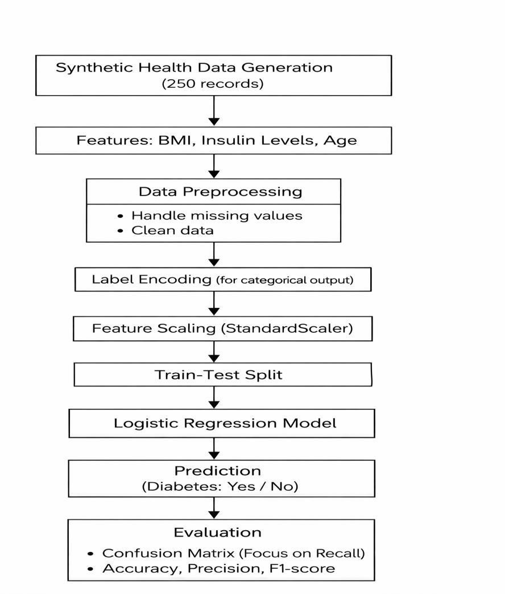

Fig. 1 Model architecture

Expected Modules/ Libraries to be used :

NumPy
NumPy is used for numerical computations and handling multi-dimensional arrays. It helps in generating synthetic data and performing mathematical operations efficiently.

Pandas
Pandas is used for data manipulation and analysis. It helps in creating and managing datasets in tabular form using DataFrames.

Matplotlib
Matplotlib is used for data visualization. It helps in plotting graphs like scatter plots and understanding data patterns visually.

Seaborn
Seaborn is a visualization library built on Matplotlib. It is used for creating advanced statistical graphs like heatmaps and distribution plots.

Scikit-learn
Scikit-learn is used for machine learning tasks. It provides tools like Logistic Regression, StandardScaler, and Confusion Matrix for model building and evaluation.

Random
The Random module is used to generate synthetic data. It helps in creating random values for features like Age, BMI, and Insulin.

Expected Evaluation metrics and Plots to be used:
Evaluation Metrics

Accuracy
Measures overall correctness of the model (total correct predictions / total samples).

Precision
Shows how many predicted diabetic cases are actually correct (important to avoid false alarms).

Recall (Most Important)
Measures how many actual diabetic patients are correctly identified (critical in medical diagnosis).

F1-Score
Harmonic mean of Precision and Recall, useful when dataset is imbalan

Plots to be Used

Confusion Matrix Heatmap
Visualizes True Positives, True Negatives, False Positives, and False Negatives (focus on Recall).

ROC Curve (Receiver Operating Characteristic)
Shows trade-off between True Positive Rate and False Positive Rate.

Precision-Recall Curve
Important when focusing on detecting diabetic cases correctly.

Feature Distribution Plots (Histogram / KDE)
Shows distribution of BMI, Insulin Levels, and Age.

Required topics from the subject:

Data Collection & Synthesis
Creating a 250-row dataset using medical ranges for BMI, insulin levels, and age to simulate real patient data.

Data Preprocessing
Cleaning and organizing data to make it suitable for machine learning models.

Label Encoding
Converting categorical outcomes (diabetic/non-diabetic) into numeric values for model use

Feature Scaling (StandardScaler)
Standardizing features so all values are on the same scale, improving model accuracy.

Logistic Regression
A classification algorithm used to predict whether a patient has diabetes or not.

Model Training & Testing
Splitting data into training and testing sets to evaluate model performance.

Confusion Matrix
A table showing correct and incorrect predictions of the model.

Recall (Sensitivity)
Measures how well the model correctly identifies actual diabetic patients.

Model Evaluation
Using metrics like accuracy and recall to check how well the model performs.

Platform Required:

Jupyter Notebook-Used for writing and running code, data analysis, and visualization. Python (IDLE / VS Code)-Used for implementing machine learning models and project development.
GitHub-Used for version control, project management, and collaboration among team members.

Books and Link Sources

- Hands-On Machine Learning with Scikit-Learn, Keras & TensorFlow – Aurélien Géron
A practical guide that explains machine learning concepts with real-world examples and Python implementation.

- Introduction to Machine Learning with Python – Andreas Müller & Sarah Guido
Covers fundamental ML concepts and emphasizes the use of Scikit-learn for building models.

- Scikit-learn Official Documentation https://scikit-learn.org
Provides detailed explanations of machine learning algorithms, preprocessing techniques, and model evaluation tools. Scikit-learn is a widely used Python library for classification, regression, and clustering tasks.

- Kaggle – Netflix Dataset & ML Projects https://www.kaggle.com
A platform for datasets and real-world ML projects. It provides Netflix-related datasets and complete ML pipelines for practice.

- Machine Learning for Absolute Beginners – Oliver Theobald
Explains core machine learning concepts and their statistical foundations in a simple and understandable way.
DATASET BOX PLOT
